SHADOWFOX | MACHINE LEARNING ENGINEER INTERNSHIP
Advanced Level Project Report
ReviewMind AI
Universal Customer Feedback Intelligence Platform
Sentiment analysis, emotion detection, topic modelling and an interactive Streamlit analytics application built with Machine Learning and Natural Language Processing.
Internship: ShadowFox Machine Learning Engineer Internship
Level: Advanced
Repository: github.com/samarthjain-ai/ShadowFox-ML-Internship
Report date: November 2026

Table of Contents
Abstract 3
1. Introduction 4
2. Dataset Description 5
3. Tools and Technologies 5
4. Methodology and System Workflow 6
5. Data Preprocessing and Exploratory Data Analysis 7
6. Model Development and Implementation 9
7. Model Evaluation and Results 12
8. Application and Backend Testing 16
9. Challenges Faced and Solutions 18
10. Results and Discussion 19
11. Limitations and Ethical Considerations 19
12. Future Improvements 20
13. Conclusion 20
References 21
Appendix A. Project Structure and Configuration 21

Abstract
Organisations receive large volumes of unstructured customer feedback that is slow and inconsistent to review by hand. ReviewMind AI is an end-to-end feedback-intelligence platform that converts raw text reviews into structured insight. Users upload a CSV or Excel file (or use a built-in demo dataset), select the feedback column, and run sentiment classification, emotion detection and topic discovery through an interactive Streamlit application with visualisations, exports and a local question-answering assistant, Ask ReviewMind.
Two sentiment classifiers were developed and compared on the IMDb movie-review dataset (50,000 reviews; 49,582 after removing 418 duplicates). A TF-IDF + Logistic Regression baseline and a fine-tuned DistilBERT model were evaluated on the same held-out test split of 9,917 reviews. Logistic Regression achieved 90.52% accuracy, 90.69% F1-score and 0.9663 ROC-AUC; DistilBERT achieved 87.56% accuracy, 87.30% F1-score and 0.9501 ROC-AUC. The DistilBERT model was fine-tuned on a balanced subset of only 4,000 reviews for two epochs on a CPU, so the comparison reflects this experimental configuration and is not a general ranking of the architectures. Emotion detection uses the pretrained DistilRoBERTa model j-hartmann/emotion-english-distilroberta-base, and topics are discovered with TF-IDF and Non-negative Matrix Factorization (NMF).
A backend integration notebook exercised the data loader, profiler, preprocessing, sentiment, emotion, topic, evaluation and orchestration modules and recorded 10 of 10 checks passed, including CSV and Excel loading, handling of missing and blank text, unlabeled data, invalid inputs, and a non-movie product-feedback dataset.
Keywords: sentiment analysis, emotion detection, topic modelling, TF-IDF, Logistic Regression, DistilBERT, NMF, Streamlit, customer feedback analytics.

1. Introduction

1.1 Background
Customer reviews, survey comments and support messages contain information about what customers value and where products and services fall short. Manually reading thousands of comments is time-consuming and makes it difficult to see recurring problems or overall opinion. Natural Language Processing (NLP) and Machine Learning (ML) can automate parts of this work by assigning sentiment labels, identifying emotional signals and grouping comments into recurring themes.

1.2 Problem Statement
Businesses need a practical way to understand large collections of unstructured feedback without building a separate analysis pipeline for every dataset. The problem addressed by this project is to design a single platform that (i) accepts arbitrary tabular feedback files, (ii) identifies the usable text and label columns, (iii) applies reliable sentiment, emotion and topic analysis, and (iv) presents the outcome through visualisations and plain-language answers, while remaining runnable locally without paid external language-model APIs.

1.3 Project Objectives
- Build a sentiment-classification workflow on the IMDb review dataset, from data inspection and cleaning to evaluation on a held-out test set.
- Compare a classical TF-IDF + Logistic Regression model with a fine-tuned DistilBERT transformer using identical test data.
- Add emotion detection with a pretrained DistilRoBERTa model and topic discovery with TF-IDF and NMF.
- Develop a modular backend that profiles data, detects text and label columns, preprocesses text and orchestrates the selected analyses.
- Deliver an interactive Streamlit application with upload, analysis, visualisation, export and a local rule-based assistant.
- Verify the backend through integration tests covering normal, unlabeled, messy and unusual inputs.

1.4 Scope of the Project
The project covers binary (positive/negative) sentiment classification, English-language emotion classification, unsupervised topic discovery and exploratory visualisation of uploaded feedback datasets. Model training and quantitative evaluation were carried out on the IMDb dataset only. The platform is designed to accept other compatible feedback datasets, and its backend was smoke-tested on a small product-feedback sample, but no quantitative evaluation on real customer-feedback domains was performed. Multilingual support, cloud deployment and production-scale benchmarking are outside the present scope.

2. Dataset Description
The primary dataset is the IMDb Movie Reviews dataset (Zenodo record 7928582), loaded from data/raw/IMDB Dataset.csv. It contains two columns: review (free text, with some HTML line-break markup) and sentiment (the labels positive and negative). The raw file is perfectly balanced, with 25,000 reviews in each class, contains no missing values, and includes 418 exact duplicate rows.
Table 1. Dataset summary (recorded in ReviewMind_AI.ipynb)
Property | Value
Raw reviews | 50,000
Positive / negative (raw) | 25,000 / 25,000 (50% / 50%)
Columns | review, sentiment
Missing values | 0 in both columns
Duplicate rows | 418
Reviews after cleaning | 49,582
Positive / negative after cleaning | 24,884 / 24,698
Training split (80%) | 39,665 reviews (19,907 positive, 19,758 negative)
Test split (20%) | 9,917 reviews (4,977 positive, 4,940 negative)

The dataset is a reproducible benchmark for binary sentiment classification. Because it consists of movie reviews, models trained on it may transfer imperfectly to product, service or other customer-feedback domains; this is discussed further in Section 11.

3. Tools and Technologies
Table 2. Technology stack
Category | Tools
Language | Python 3.11.9
Application framework | Streamlit
Data processing | Pandas 3.1.1, NumPy 2.4.6
Machine learning | Scikit-learn 1.9.1 (TfidfVectorizer, LogisticRegression, NMF, metrics)
Deep learning / NLP | PyTorch 2.15.0 (CPU build), Hugging Face Transformers 5.22.2, Accelerate 1.15.0
Pretrained models | distilbert/distilbert-base-uncased (fine-tuned); j-hartmann/emotion-english-distilroberta-base
Visualisation | Matplotlib, Seaborn, Streamlit charts
Model storage | Joblib (.pkl) and Hugging Face save_pretrained artifacts
Development | Jupyter Notebook, Visual Studio Code
Version control | Git and GitHub

Versions are those printed by the notebooks on the development machine (a Windows system running a CPU-only PyTorch build). No GPU was available, which influenced the DistilBERT training design described in Section 6.

4. Methodology and System Workflow
The project has two connected parts. The model-development notebook (ReviewMind_AI.ipynb) trains and evaluates the sentiment models. The application and backend (app/app.py and the src/ modules) package those models, together with emotion detection and topic modelling, into a tool that works on any uploaded feedback file.
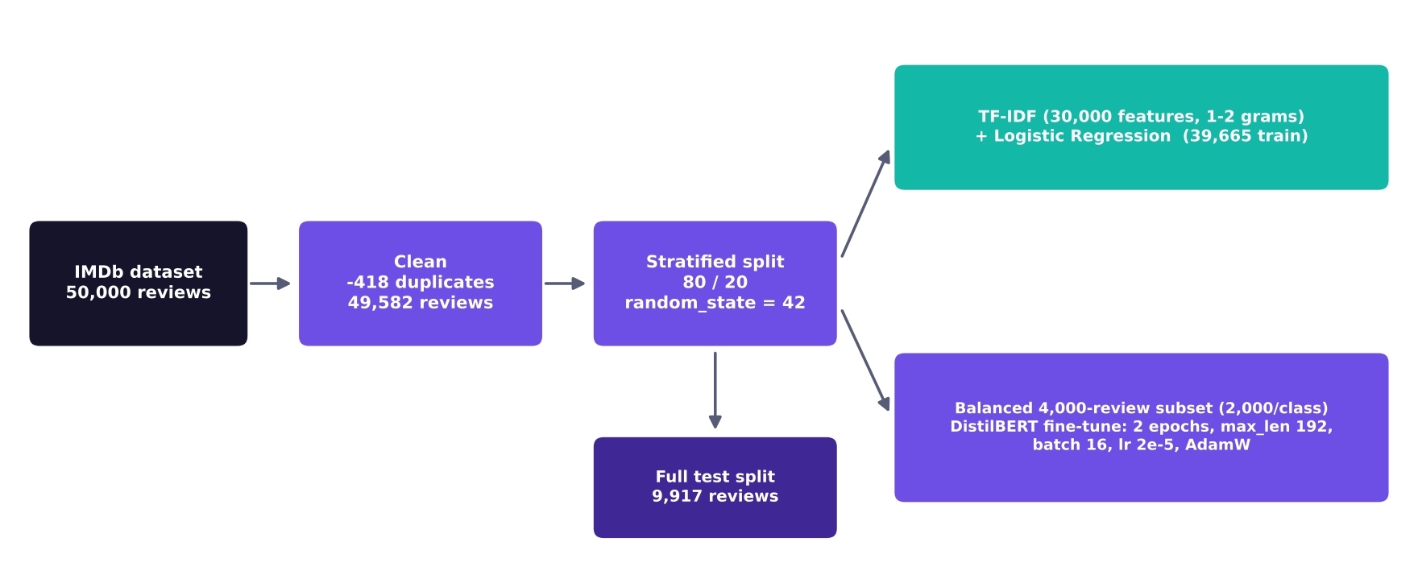
Figure 1. Model-development pipeline reconstructed from the recorded notebook configuration and outputs.

4.1 Application Workflow
- The user uploads a CSV or Excel file or selects the demo dataset. For Excel files the worksheet and header row can be chosen.
- The application profiles the dataset: rows, columns, missing values, duplicate rows, empty rows, data types and blank strings.
- Candidate feedback text columns and ground-truth label columns are detected; the user confirms the feedback column and, optionally, a label column.
- The user chooses Automatic mode (sentiment, emotion and topics, plus evaluation when a valid label is available) or Custom mode, and selects the sentiment model (TF-IDF + Logistic Regression or DistilBERT).
- Rows with missing or blank feedback are excluded from prediction; predictions, confidences, emotions and topics are appended to a results table.
- Results are explored through the Visualization Center, exported as CSV or a PDF report, and queried through Ask ReviewMind.
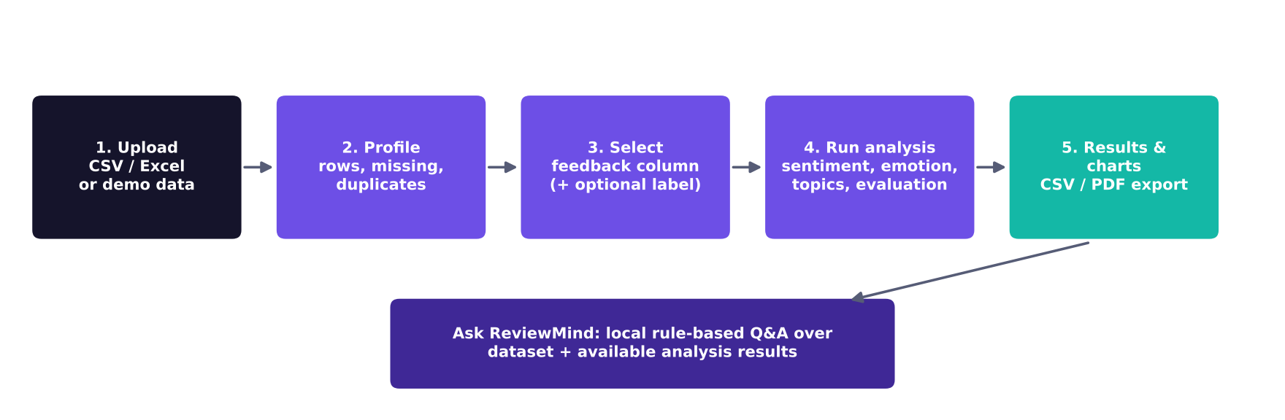
Figure 2. Processing workflow of the ReviewMind AI application, derived from the structure of app/app.py.

4.2 Modular Backend
The backend modules named in the project structure and imported by the notebooks and the application are data_loader (CSV/Excel loading and workbook inspection), data_profiler (profiling, text/label column detection and feedback-column validation), preprocessing (text cleaning), sentiment, emotion, topics, evaluation, analysis_engine (run_analysis and run_automatic_analysis), assistant_engine, visualization and exporter. Separating these concerns allows each function to be tested independently, as done in the backend testing notebook (Section 8).

5. Data Preprocessing and Exploratory Data Analysis

5.1 Data Quality Inspection and Cleaning
The raw dataset was inspected for missing values, duplicates and label balance. No values were missing, but 418 rows were exact duplicates. Duplicates and any rows missing a required field were dropped and the index was reset, leaving 49,582 reviews. Duplicate removal prevents repeated examples from influencing the fitted model and from appearing in both the training and test sets.
Reviews contain HTML line-break markup (<br />). Before vectorisation this markup was replaced by a space using a regular expression so that markup tokens do not become model features. The label column was mapped to integers (negative = 0, positive = 1). The backend clean_text function performs equivalent cleaning for uploaded data; the recorded sample outputs show the markup removed while the review text is preserved.

5.2 Class Distribution
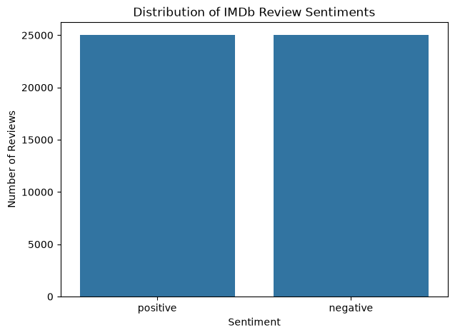
Figure 3. Distribution of sentiments in the raw IMDb dataset: 25,000 positive and 25,000 negative reviews (notebook output).
The count plot confirms that the raw dataset is perfectly balanced. After duplicate removal the proportions remain almost equal (24,884 positive and 24,698 negative), so accuracy is a meaningful headline metric and no class-rebalancing technique was required.

5.3 Review Length Analysis
Table 3. Review length statistics in words (cleaned dataset, n = 49,582)
Statistic | Words
Mean | 231.35
Standard deviation | 171.54
Minimum | 4
25th percentile | 126
Median | 173
75th percentile | 281
90th percentile | 452
95th percentile | 591
99th percentile | 908
Maximum | 2,470

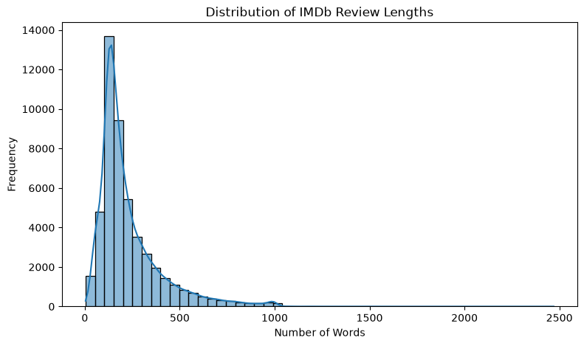
Figure 4. Distribution of IMDb review lengths in words (notebook output).
Review length is strongly right-skewed: most reviews are under 300 words, while a small number exceed 1,000 words. This matters for transformer models, which accept a fixed maximum sequence length. The notebook uses 192 tokens for DistilBERT, so longer reviews are truncated and some information is necessarily lost. The TF-IDF model reads the full text.

5.4 Train/Test Split
Cleaned reviews were split 80/20 with train_test_split(test_size=0.20, random_state=42, stratify=y). Stratification preserves the class proportions in both partitions (Table 1), and the fixed seed makes the experiment reproducible. The TF-IDF vectoriser was fitted on the training text only and then applied to the test text, preventing vocabulary leakage from the test set.

6. Model Development and Implementation

6.1 Sentiment Model 1: TF-IDF + Logistic Regression
Term Frequency–Inverse Document Frequency (TF-IDF) represents each review as a sparse vector in which terms are weighted by how often they occur in the review and how distinctive they are across the corpus. Logistic Regression then learns a linear decision boundary over these vectors and outputs class probabilities, which the application reports as confidence scores. The approach is fast, requires no GPU and keeps word and phrase weights relatively interpretable.
Table 4. TF-IDF and Logistic Regression configuration
Parameter | Value
max_features | 30,000
ngram_range | (1, 2): unigrams and bigrams
min_df | 2 (drop terms seen only once)
max_df | 0.95 (drop extremely common terms)
Training matrix shape | 39,665 × 30,000
Test matrix shape | 9,917 × 30,000
Classifier | LogisticRegression(max_iter=1000, random_state=42)
Saved artifact | models/tfidf_logistic_regression.pkl (vectoriser + model, saved with Joblib)

The vectoriser and model are stored together because the classifier depends on the exact vocabulary and feature mapping of the vectoriser. The notebook reloads the artifact and verifies it on three example reviews: a clearly positive review is classified positive, a clearly negative review negative, and a mixed review ("some good moments but the overall experience was disappointing") negative.

6.2 Sentiment Model 2: Fine-tuned DistilBERT
DistilBERT is a compact transformer distilled from BERT that produces contextual token representations, allowing the classifier to take word order and surrounding context into account. The pretrained distilbert/distilbert-base-uncased checkpoint was loaded with a two-class classification head; the Hugging Face load report confirms that the classifier and pre-classifier layers were newly initialised and therefore required fine-tuning.
Because training ran on a CPU, a balanced subset of 2,000 positive and 2,000 negative training reviews (4,000 in total) was sampled with random_state=42, together with a 1,000-review test subset (500 per class) used for a first evaluation. Reviews were tokenised with truncation and padding to a maximum length of 192 tokens.
Table 5. DistilBERT fine-tuning configuration
Parameter | Value
Base checkpoint | distilbert/distilbert-base-uncased, 2 labels
Device | CPU (CUDA not available)
Training data | 4,000 reviews (2,000 per class)
Maximum sequence length | 192 tokens
Batch size | 16 (250 steps per epoch)
Epochs / total steps | 2 / 500
Optimiser | AdamW, learning rate 2e-5
Scheduler | Linear schedule with 10% warm-up (50 steps)
Gradient clipping | Maximum norm 1.0
Saved artifact | models/distilbert_imdb_sentiment/ (config, safetensors weights, tokenizer)

A custom PyTorch loop was used instead of a high-level trainer: for each batch the gradients are zeroed, the loss is computed, back-propagated and clipped, and the optimiser and scheduler are stepped. The loss was logged every 25 batches. Training took about 17.8 minutes per epoch, or roughly 35.7 minutes in total.

6.3 Emotion Detection
Emotion detection uses the pretrained j-hartmann/emotion-english-distilroberta-base model through a Hugging Face text-classification pipeline on CPU, with truncation enabled. It was not fine-tuned or retrained in this project. In the recorded runs it returned the labels joy, sadness, surprise, disgust, fear and neutral. The model is downloaded to models/emotion_english_distilroberta/ for local use. The backend wrapper returns an empty list for empty, None or blank input rather than raising an error.

6.4 Topic Modelling
Topics are discovered without labels using TF-IDF features and Non-negative Matrix Factorization (NMF), which decomposes the document-term matrix into a small number of additive topics, each characterised by its highest-weighted keywords. The recorded run used TfidfVectorizer(max_features=5000, min_df=2, max_df=0.95, stop_words="english") and NMF(n_components=5, init="nndsvda", max_iter=400, random_state=42). Each document is assigned to its dominant topic.

6.5 Ask ReviewMind: Local Rule-Based Assistant
Ask ReviewMind is a floating chat assistant that answers a defined set of question categories (Dataset Overview, Sentiment Analysis, Emotion Analysis, Topics and Keywords, Customer Complaints and Business Insights) from the uploaded dataset and the available analysis results. It is rule-based and runs locally, so it does not depend on a paid external language-model API. Responses can include small charts (the code limits these to six), and the assistant state is reset when the dataset changes so that answers never refer to a previous file.

7. Model Evaluation and Results
Both sentiment models were evaluated on the same held-out test split of 9,917 reviews that neither model saw during training. Metrics use the positive class as the reference: precision is the fraction of predicted positives that are truly positive, recall the fraction of actual positives found, F1 their harmonic mean, and ROC-AUC the ranking quality of the predicted probabilities across thresholds.

7.1 TF-IDF + Logistic Regression
Table 6. Logistic Regression performance on the full test split (n = 9,917)
Metric | Result
Accuracy | 0.9052 (90.52%)
Precision | 0.8945
Recall | 0.9196
F1-score | 0.9069
ROC-AUC | 0.9663

Table 7. Logistic Regression confusion matrix
 | Predicted Negative | Predicted Positive
Actual Negative | 4,400 | 540
Actual Positive | 400 | 4,577

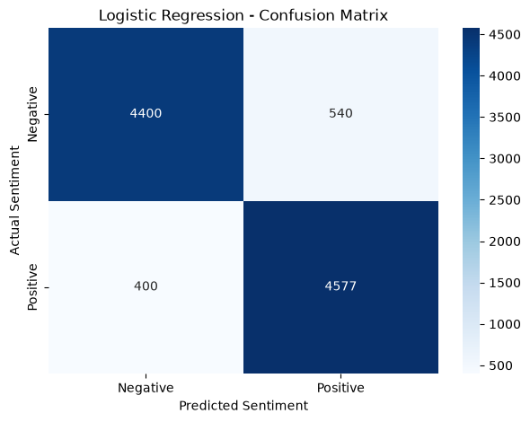
Figure 5. Logistic Regression confusion matrix on the 9,917-review test split (notebook output).
The model makes 940 incorrect predictions (540 false positives and 400 false negatives), an error rate of about 9.5%. Per-class F1 is balanced (0.90 for negative, 0.91 for positive), consistent with the balanced test split.
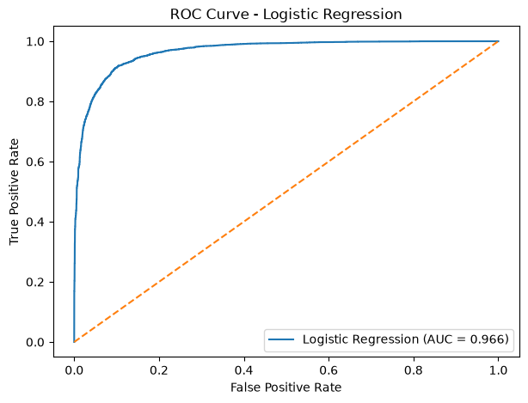
Figure 6. ROC curve of the Logistic Regression model, AUC = 0.966 (notebook output).
The ROC curve stays close to the upper-left corner, showing that the model ranks positive reviews above negative reviews well across probability thresholds.

7.2 Fine-tuned DistilBERT
Table 8. DistilBERT training history
Epoch | Average training loss | Time (seconds) | Time (minutes)
1 | 0.4410 | 1,069.86 | 17.83
2 | 0.2297 | 1,072.80 | 17.88

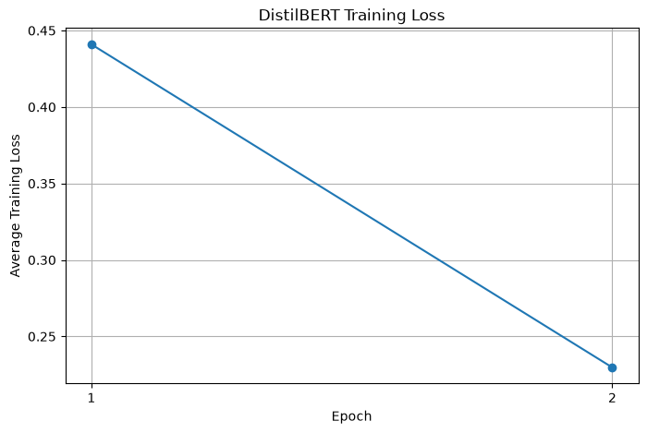
Figure 7. Average DistilBERT training loss by epoch (notebook output).
Average training loss fell from 0.4410 to 0.2297, showing that the model learned from the 4,000 training reviews. Loss alone does not establish generalisation, so the held-out metrics below are the relevant evidence.
Table 9. DistilBERT evaluation: 1,000-review subset versus full test split
Metric | Subset (n = 1,000) | Full test split (n = 9,917)
Accuracy | 0.8700 | 0.8756
Precision | 0.8887 | 0.8947
Recall | 0.8460 | 0.8523
F1-score | 0.8668 | 0.8730
ROC-AUC | 0.9517 | 0.9501

The subset results are close to the full-split results, so the subset was a reasonable preview, but the full 9,917-review split is the appropriate basis for comparison with Logistic Regression.
Table 10. DistilBERT confusion matrix (full test split)
 | Predicted Negative | Predicted Positive
Actual Negative | 4,441 | 499
Actual Positive | 735 | 4,242

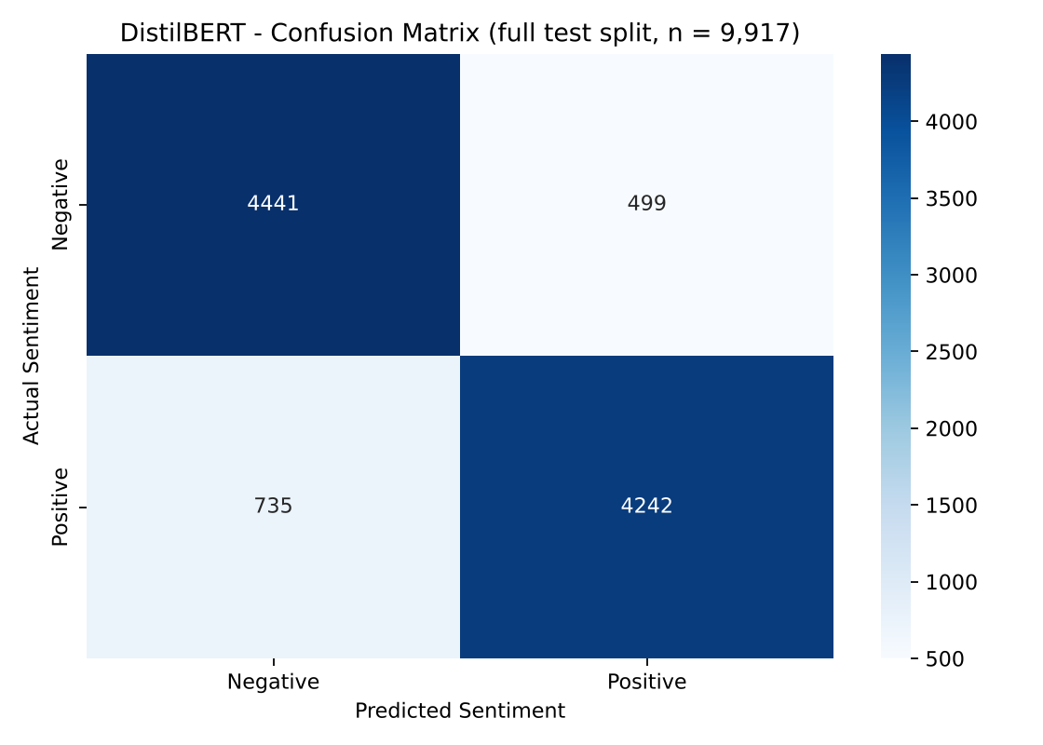
Figure 8. DistilBERT confusion matrix on the full test split, re-plotted from the counts recorded in the notebook output.
DistilBERT makes 1,234 errors (499 false positives and 735 false negatives), about 12.4%. Its errors are asymmetric: it misses more positive reviews than it wrongly flags, which explains its lower recall (0.8523) relative to its precision (0.8947).

7.3 Model Comparison
Table 11. Logistic Regression versus DistilBERT on the same 9,917-review test split
Metric | Logistic Regression | DistilBERT | Difference (LR − DB)
Accuracy | 0.9052 | 0.8756 | +0.0296
Precision | 0.8945 | 0.8947 | −0.0002
Recall | 0.9196 | 0.8523 | +0.0673
F1-score | 0.9069 | 0.8730 | +0.0339
ROC-AUC | 0.9663 | 0.9501 | +0.0162

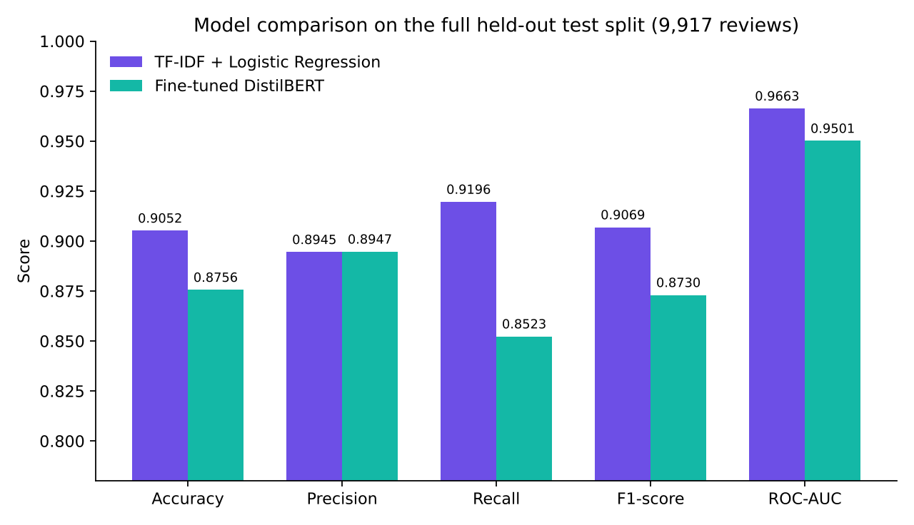
Figure 9. Side-by-side metrics for both sentiment models, re-plotted from the values recorded in the notebook comparison table.
Logistic Regression is the stronger model on accuracy, recall, F1-score and ROC-AUC in this experiment, while precision is effectively tied (0.8945 versus 0.8947). The difference column was computed from the recorded values.

7.4 Error Analysis
The notebook pairs every test review with its actual label, prediction and positive-class probability and displays five false positives and five false negatives. Several of the displayed reviews begin with wording that suggests mixed sentiment, for example a negative review opening "Despite being a huge fan of Fred Astaire and G..." that was predicted positive, and a positive review opening "This isn't exactly a great film, but I admire..." that was predicted negative. A bag-of-words model detects strongly polarised terms but cannot reliably resolve such contrasts. This is an observation from the few displayed examples and was not quantified across all 940 errors.

8. Application and Backend Testing

8.1 Streamlit Application
The Streamlit application (app/app.py, styled by app/style.css) presents a sidebar for choosing the data source and the workspace, and five workspaces:
- Overview: dataset health metrics (rows, columns, missing values, duplicate rows, empty rows) and an expandable schema and data-quality table.
- Analyze: feedback-column selection with a recommended column and usable-row coverage, an optional ground-truth label, Automatic or Custom mode, model choice and a Run analysis button; results include original, analysed and excluded row counts, evaluation metrics when labels exist, a results table and a CSV download.
- Visualizations: a Custom Graph Builder plus supported charts that appear only when the data allows them: sentiment donut, emotion distribution, topic frequency, rating distribution, keyword frequency, date trend, numeric distribution and correlation heatmap, each with a PNG download.
- Exports: analysis CSV and a generated PDF report.
- Key Terms: plain-language definitions of sentiment, emotions, confidence score, TF-IDF, Logistic Regression, DistilBERT, topic modelling and evaluation metrics.
The interface uses a violet and teal colour scheme with a dark sidebar, and the sidebar states the platform's design principles: no paid APIs, no arbitrary code execution and original data preserved. The original uploaded data is kept unchanged and analysis results are stored separately. Widget state is preserved when the user moves between workspaces so that configuration and results are not lost.

8.2 Backend Integration Testing
The notebook ReviewMind_Backend_Testing.ipynb is an integration smoke test of the public backend functions; it does not retrain models. Its recorded test report lists ten passed checks.
Table 12. Backend integration test report (recorded output: 10/10 passed)
Check | Result
Dataset loading and profiling | PASS
Sentiment + emotion + topics + evaluation in one run | PASS
Prediction output consistency (expected columns, row count) | PASS
Custom sentiment-only analysis | PASS
Custom emotion-only analysis | PASS
Default analysis (sentiment + topics) | PASS
Unlabeled dataset (evaluation skipped) | PASS
Missing and blank text (30 rows in, 27 analysed) | PASS
CSV and Excel loading (20 × 2 each) | PASS
Different feedback dataset (20 product comments) | PASS

Further checks confirmed that invalid inputs raise informative errors: an unknown text column ("Text column 'wrong_column' not found."), an empty dataset, an unsupported analysis name, and a column with no usable text. The automatic analysis mode selected sentiment, emotion, topics and evaluation for the labelled IMDb sample, and only sentiment, emotion and topics for the unlabelled product-feedback sample. Column detection correctly identified review and sentiment in the IMDb data and customer_feedback in the product data, and an export test wrote outputs/product_feedback_analysis.csv.

8.3 Integrated Analysis Output
Running all four analyses on the first 100 IMDb reviews produced the columns predicted_sentiment, sentiment_confidence, predicted_emotion, emotion_confidence and discovered_topic. The recorded distributions are shown in Figure 10.
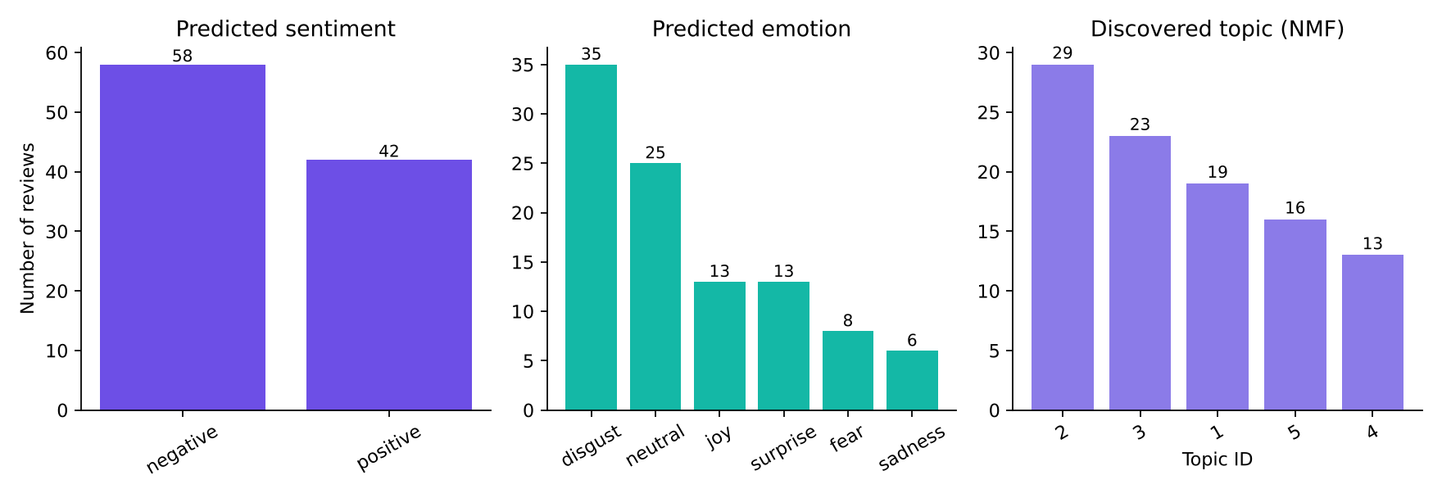
Figure 10. Predicted sentiment, emotion and topic distributions for the first 100 IMDb reviews, re-plotted from the recorded integration-test output.
The integrated evaluation on these 100 reviews reported 96% accuracy (confusion matrix [[56, 2], [2, 40]]). This figure should not be read as a performance estimate: the 100 reviews are the first rows of the raw dataset, which may overlap with the data on which the Logistic Regression model was trained, and the sample is small. The held-out results in Section 7 are the valid measure of model quality.
Table 13. Topics discovered by NMF on the first 100 reviews (recorded output)
Topic | Top keywords
1 | br, movie, say, just, young, great, characters, scene
2 | movie, like, actors, bad, good, watch, just, thing
3 | film, just, version, story, films, did, lot, far
4 | war, br, film, hollywood, mountain, romantic, beautiful, story
5 | movies, seen, japanese, horror, ve, tv, series, water

The keywords describe recurring vocabulary rather than verified business categories, and the topics should be read as broad exploratory themes. The residual token br in topics 1 and 4 comes from HTML line-break markup: this call passed the raw review text directly to discover_topics, so the markup was not removed. Cleaning text with clean_text before topic modelling avoids this.
Table 14. Emotion predictions on five hand-written sentences (recorded output)
Sentence (abridged) | Predicted emotion | Confidence
"This movie was absolutely fantastic. I loved every moment!" | joy | 0.9716
"I am extremely disappointed with this terrible movie." | fear | 0.4298
"The movie made me feel very sad and emotional." | sadness | 0.9864
"I was surprised by the unexpected ending." | surprise | 0.9831
"It was an ordinary movie with nothing particularly special." | surprise | 0.6098

Clear emotional statements receive high-confidence labels, whereas the ambiguous second and fifth sentences receive low or moderate confidence and arguably unexpected labels (fear for disappointment, surprise for an ordinary movie). This illustrates why confidence scores are shown to users and why emotion output should be reviewed rather than treated as fact.

9. Challenges Faced and Solutions
Table 15. Challenges identified in the project materials and how they were addressed
Challenge | Solution or mitigation
No GPU available for transformer training | DistilBERT was fine-tuned on a balanced 4,000-review subset for two epochs with a 192-token maximum length; training still required about 35.7 minutes.
Noisy text: HTML <br /> markup and 418 duplicate reviews | Duplicates were dropped; markup was replaced by spaces before vectorisation; the backend clean_text function applies the same idea to uploaded data.
Long reviews versus a fixed transformer input length | Review-length percentiles were analysed (median 173 words, 90th percentile 452) and truncation was acknowledged as a limitation of the DistilBERT run.
Fair comparison of two differently trained models | Both models were evaluated on the identical 9,917-review test split, and the unequal training conditions are stated explicitly.
Emotion model download interrupted and local disk space reported insufficient | Download timeouts were raised, a single download worker was used, and the model was stored in models/emotion_english_distilroberta/, after which local loading and inference succeeded.
Large DistilBERT weights cannot be stored in the GitHub repository | The repository documents that the weights must be supplied through a model-hosting or download process before that model is used.
Uploaded datasets with missing, blank or unlabeled text | Blank rows are excluded from prediction but accounted for (30 rows in, 27 analysed in the test); evaluation is skipped with a clear message when no valid label exists.
A newly added function not visible in a running notebook session | The module was inspected and reloaded with importlib.reload, confirming run_automatic_analysis was available.
Streamlit state lost when navigating between pages | Widget values are persisted across workspaces and the loaded dataset is cached against a cheap source key to avoid re-reading the file on each interaction.

10. Results and Discussion
The central quantitative result is that the TF-IDF + Logistic Regression baseline outperformed the fine-tuned DistilBERT model on the IMDb held-out split: 90.52% versus 87.56% accuracy and 0.9663 versus 0.9501 ROC-AUC. Precision is essentially identical, so the gap arises mainly from recall: DistilBERT misses 735 positive reviews compared with 400 for Logistic Regression.
Several features of the experimental design explain why this result should not be generalised. First, Logistic Regression was trained on all 39,665 training reviews whereas DistilBERT saw only 4,000, about 10% of the data. Second, DistilBERT was fine-tuned for only two epochs with reviews truncated to 192 tokens, although the average review contains 231 words. Third, long movie reviews contain many strongly polarised words and bigrams, which are exactly the signals a TF-IDF model captures well. A transformer trained on more data, for longer, with longer inputs, would be expected to narrow the gap, but this was not tested and the project makes no claim about it.
The practical conclusion for the platform is that both models are offered: the lightweight TF-IDF model is fast, needs no GPU and delivered the best measured accuracy, while DistilBERT remains available as a contextual alternative. Emotion detection and topic modelling extend the platform beyond polarity, but they were demonstrated through integration tests and sample outputs rather than quantitative benchmarks, because the emotion and topic components have no ground-truth labels in the dataset.
From an engineering perspective, the backend tests show that the platform is robust to the input variation expected from real uploads (blank rows, missing labels, alternative column names, Excel files) and that errors are reported clearly. The modular design, with a single orchestration function selecting which analyses run, allows the application to adapt to different datasets without code changes.

11. Limitations and Ethical Considerations

11.1 Limitations
- Training and quantitative evaluation used only IMDb movie reviews; sentiment predictions may be less reliable for datasets whose language or subject matter differs substantially.
- Sentiment is binary; neutral and mixed opinions are forced into positive or negative.
- DistilBERT was trained on a 4,000-review subset for two epochs with truncated inputs because of CPU constraints, so its measured performance is not a ceiling for the architecture.
- Emotion classification can misinterpret ambiguous or context-dependent text, as the recorded examples show, and it was not quantitatively evaluated here.
- Topic modelling depends on the quality and quantity of feedback; topics are exploratory keyword groups, and the recorded keywords include residual markup (br) when raw text is passed directly.
- Ask ReviewMind is a rule-based assistant limited to defined question categories; it is not a general conversational model.
- Some visualisations require particular column types such as dates or numeric ratings.
- The DistilBERT weights are not distributed through the repository and must be made available separately.

11.2 Ethical Considerations
- Predictions are analytical estimates and should not be treated as verified facts about individual customers.
- Customer feedback may contain personal or sensitive information; users should upload only data they are authorised to process. The application runs locally and does not call paid external APIs.
- Models may reflect biases or limitations of the IMDb training data, and business decisions should not rely exclusively on automated sentiment or emotion output.

12. Future Improvements
- Evaluate and adapt the models on real customer-feedback datasets from several industries (domain adaptation).
- Fine-tune DistilBERT on the full training split with a validation set, longer sequences and more epochs, ideally on a GPU, and repeat the comparison under equal conditions.
- Add neutral or fine-grained sentiment classes and multi-lingual support.
- Improve topic discovery, for example by cleaning markup before modelling, tuning the number of topics and adding coherence measures.
- Expand the assistant's conversational coverage and the reporting and visualisation options.
- Optimise model size and loading for cloud deployment and publish a hosted demonstration.
- Extend automated testing (test modules for the assistant, data quality, visualisation and export are listed in the repository's tests/ folder) across more datasets.

13. Conclusion
ReviewMind AI demonstrates a complete machine-learning workflow, from data inspection and cleaning through model training, evaluation, persistence and integration into an interactive application. On a held-out IMDb test split of 9,917 reviews, TF-IDF with Logistic Regression reached 90.52% accuracy and a 0.9663 ROC-AUC, outperforming a CPU-trained DistilBERT model that reached 87.56% accuracy and a 0.9501 ROC-AUC under reduced training conditions. The platform also provides emotion detection, topic discovery, visual analytics, exports and a local rule-based assistant, and its backend passed all ten recorded integration checks.
The project's most important lessons are methodological: compare models on identical test data, state the training conditions behind each result, and treat integration-test output as evidence of correct behaviour rather than of model quality. The documented limitations, particularly the single-domain training data, define clear next steps for making the platform dependable on real customer feedback.

References
[1] IMDb Movie Reviews dataset (50,000 reviews). Zenodo. https://zenodo.org/records/7928582
[2] Maas, A. L., Daly, R. E., Pham, P. T., Huang, D., Ng, A. Y., & Potts, C. (2011). Learning word vectors for sentiment analysis. Proceedings of ACL-HLT, 142–150.
[3] Sanh, V., Debut, L., Chaumond, J., & Wolf, T. (2019). DistilBERT, a distilled version of BERT: smaller, faster, cheaper and lighter. arXiv:1910.01108. https://arxiv.org/abs/1910.01108
[4] Lee, D. D., & Seung, H. S. (1999). Learning the parts of objects by non-negative matrix factorization. Nature, 401, 788–791.
[5] Pedregosa, F., et al. (2011). Scikit-learn: Machine learning in Python. Journal of Machine Learning Research, 12, 2825–2830. https://scikit-learn.org/stable/
[6] Wolf, T., et al. (2020). Transformers: State-of-the-art natural language processing. Proceedings of EMNLP: System Demonstrations, 38–45. https://huggingface.co/docs/transformers/
[7] Hartmann, J. Emotion English DistilRoBERTa-base (model card). Hugging Face. https://huggingface.co/j-hartmann/emotion-english-distilroberta-base
[8] PyTorch documentation. https://pytorch.org/docs/stable/
[9] Streamlit documentation. https://docs.streamlit.io/
[10] ReviewMind AI project repository and README. https://github.com/samarthjain-ai/ShadowFox-ML-Internship

Appendix A. Project Structure and Configuration
The repository layout documented in the project README is reproduced below.
ReviewMind-AI/
.streamlit/config.toml
app/ app.py, style.css
backups/
data/raw/ IMDB Dataset.csv
models/ distilbert_imdb_sentiment/, tfidf_logistic_regression.pkl
notebooks/ ReviewMind_AI.ipynb, ReviewMind_Backend_Testing.ipynb
outputs/ product_feedback_analysis.csv
src/ analysis_engine, assistant_engine, data_loader, data_profiler,
emotion, evaluation, exporter, preprocessing, sentiment,
topics, visualization
tests/ test_assistant_engine, test_data_quality,
test_visualization_and_export
requirements.txt, .gitignore, README.md

Running the application. Clone the repository, create and activate a virtual environment, run pip install -r requirements.txt, and start the app with streamlit run app/app.py. The DistilBERT weights must be supplied separately before that model is selected.

